September 22
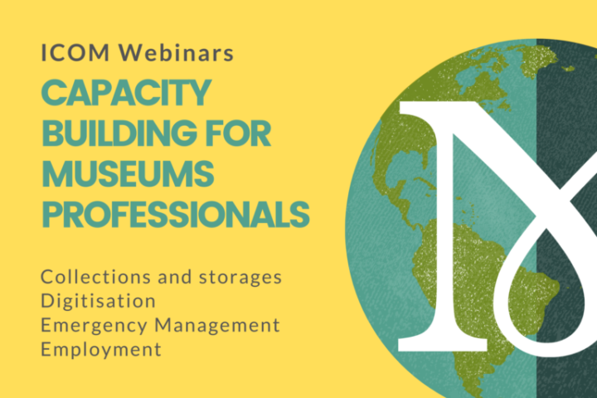
ICOM Webinars | Capacity building for museums professionals

In a difficult time for museums, ICOM remains a point of support for museum professionals and is proud to announce the launch of a new series of webinars: four online seminars that will provide a space for reflection and discussion on relevant current topics for the museum sector.
The webinars will bring together speakers from different regions who will share their experiences and thoughts on the challenges facing contemporary museums. Each webinar will have the participation of four specialists from different regions of the world.
The online discussions are created with the goal of promoting dialogue and exchange of knowledge between museum professionals from different countries, and developing a forum that promotes reflection and allows professionals to exchange ideas on topics of wide importance for the museums of today.
The webinars will be streamed, with simultaneous translation in French, English and Spanish.
***
The following webinars will cover the following topics:
• New challenges for collections and storage areas – 7 October, 15:00 Paris time
Many museums were completely closed for several months, exposing their storage areas to numerous risks to the collections. In the future, the shortage of manpower and funds for the maintenance of collections will be a challenge. It is in this context that the expert group will be able to discuss: best practices in collection preservation; access to collections in storage; and risk management for collections.
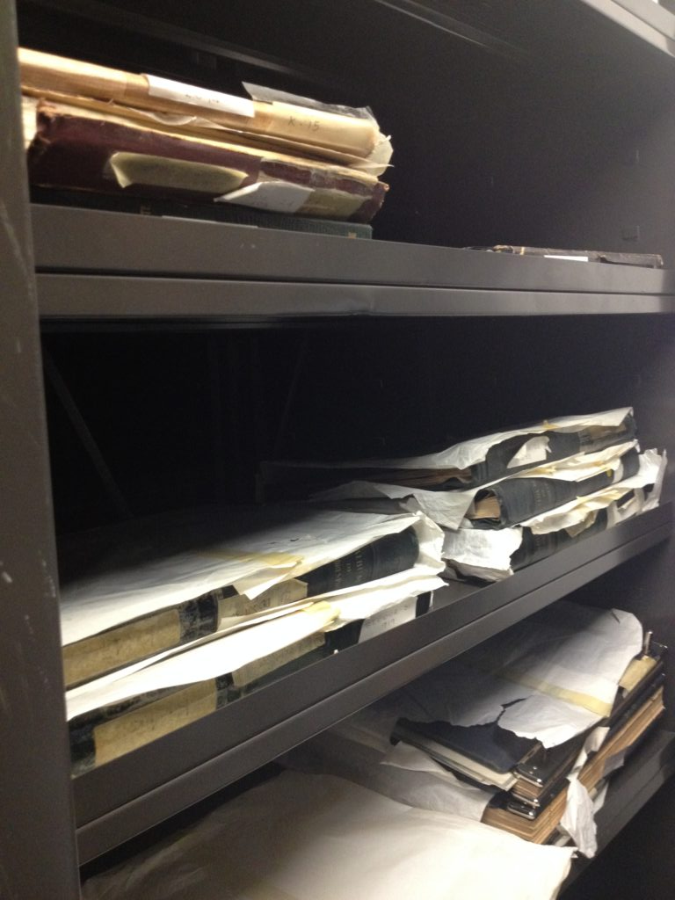

• Digitisation of activities – 21 October
The discussion will be focused on strategies and skills that enable museums and professionals to harness the power of digital media. This session will present good practices on how to foster continuous learning, reach out to our communities at a distance and generate additional revenue to address the lack of on-site visitors.
• Emergency Management (Focus: Lebanon) – 4 November
The session will bring together experts and museum professionals to discuss a subject of the utmost importance and more topical than ever: the management of emergency situations. The fundamentals of emergency planning, including preparedness, identification of key players, risk assessment, collection prioritization and other preparations will be discussed. Special attention will be given to the situation in Beirut, Lebanon, whose museums were severely affected by the double explosion on 4 August.
• Stimulating employment in museums – 18 November
This last webinar will repeal the consequences of the pandemic for museum professionals, proposing new models for dealing with the crisis. This session will present the results of a second survey on the impact of COVID-19 on the sector, an overview of emerging professions, and will highlight the role that museums can play as promoters of local development after the crisis.
Please follow our social media (link Facebook, Twitter, Instagram) to stay informed about these and another ICOM digital activities

