September 23-ICOM France Conference ‘And now, recovery…. thinking about the post-crisis museum’
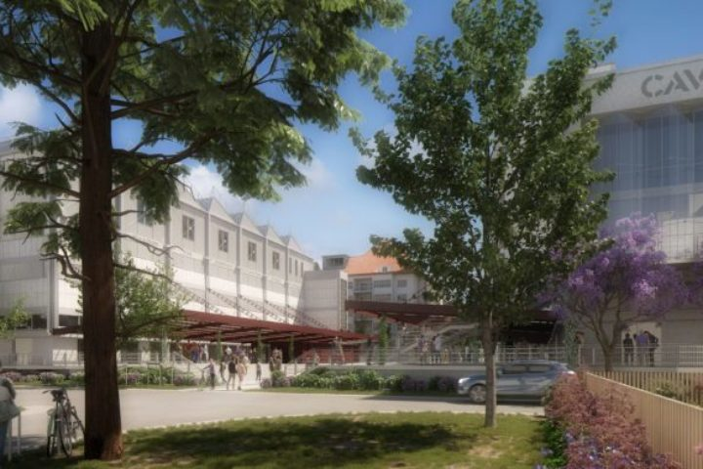

As part of the professional day organised by ICOM France ‘And now, recovery…. thinking about the post-crisis museum’, the morning of 25 September will be devoted to the place that museums can/should take in post-covid reconstruction to convey the values of knowledge sharing, solidarity, proximity and sustainability.
The President of ICOM, Alberto Garlandini, will give a speech at the opening of the conference and the results of the ICOM survey on the COVID crisis in museums will be presented as part of the report of the health crisis on museums in the world and in France.
In addition, a round table will highlight the theme: ‘Culture at the heart of recovery… the museum’s role and mission’. It will bring together Hervé Barbaret, Director General of Agence France-Muséums; Alexandre Chevalier, President of ICOM Belgium; Jean-François Chougnet, President of the MuCEM; Philippe Guillet, Director of the Nantes Natural History Museum; Paul Lang, Director of the Museums of the City of Strasbourg; Pia Müller-Tamm, Director of the Kunsthalle Karlsruhe; Sylvie Ramond, Director of the Lyon MBA/MAC Museums Centre.
All ICOM members will be able to connect to the digital platform without prior registration, and have access to simultaneous translation in English.
- Friday 25 September from 9am to 1pm
‘And now, recovery…. thinking about the post-crisis museum’
Participate in the session
Meeting ID: 823 8798 8401 / Code: 318096

